**Sprint 2**

**Particulars**

| **Query** | **Reply** |
| --- | --- |
| Sprint Start Date | 31 October 2022 |
| Sprint End Date | 05 November 2022 |
| Issues Count | 3 |
| Total Story Points | 7 |
| Sprint Release Date (Planned) | 05 November 2022 |
| Sprint Release Date (Actual) | 05 Novemeber 2022 |

**Outcomes**

* A customer can create a new ticket with the detailed description of the query
* A customer can see all the tickets that he/she has raised in the dashboard
* An agent can register in the application
* Admin can accept/deny the request of the agent
* Admin can assign the tickets raised to the confirmed agents

**Screenshots**

**1. Customer - Raise a new ticket**

[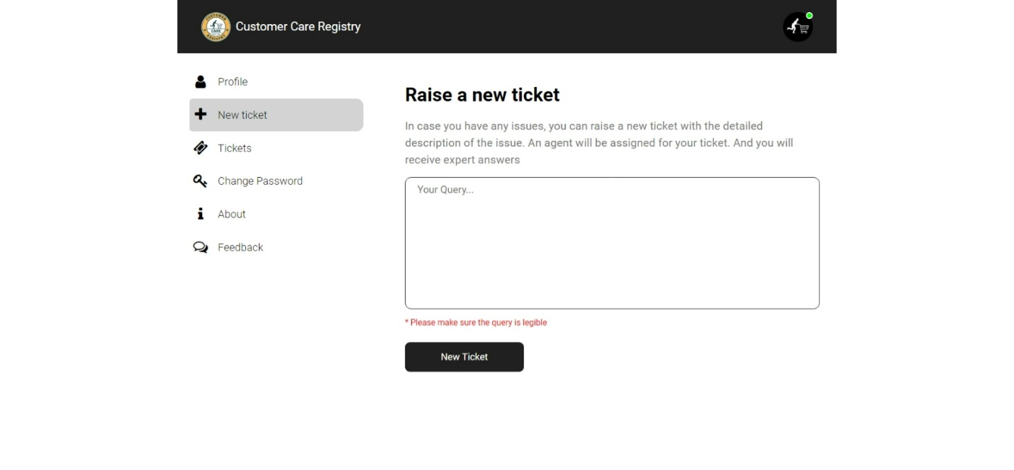](https://user-images.githubusercontent.com/87432281/200056671-7e5709ee-5474-453a-a5d4-d6624fe3a066.jpeg)

**2. Customer - All tickets raised**

[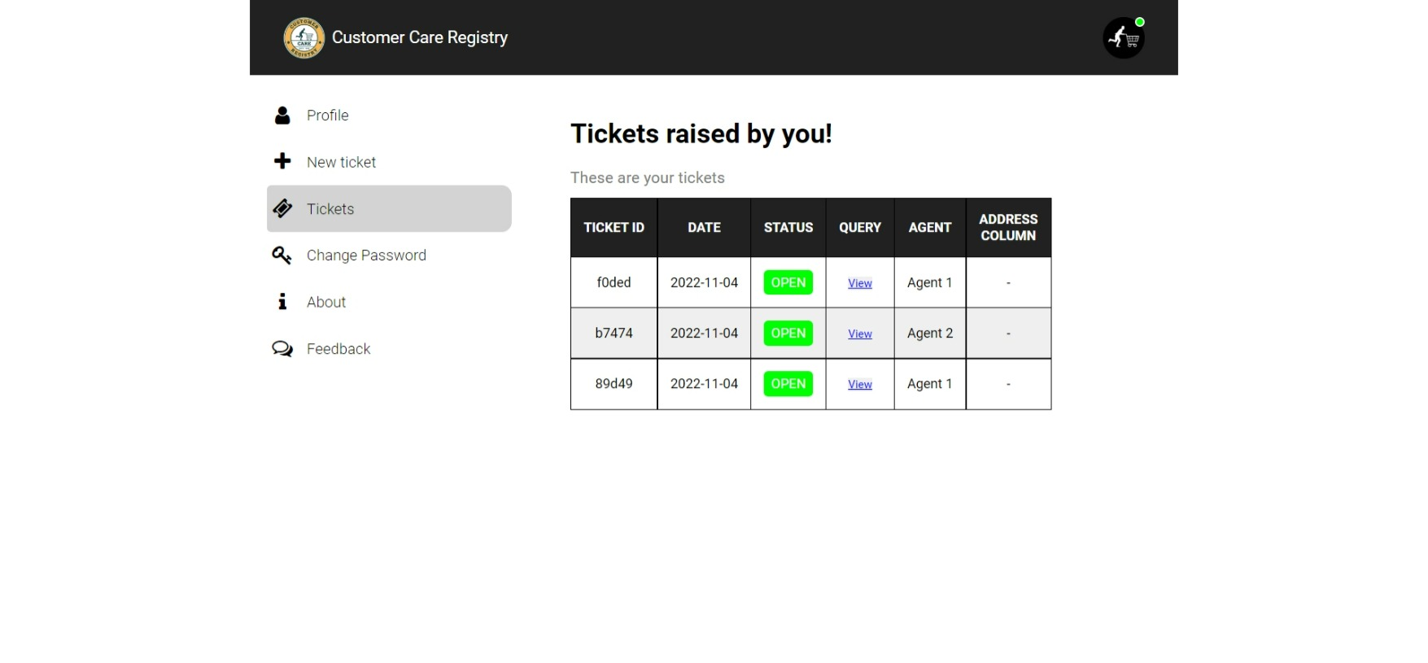](https://user-images.githubusercontent.com/87432281/200056812-98719e69-cc5c-425f-bad6-d6b9e1d0a984.jpeg)

**3. Admin - Unassigned tickets**

[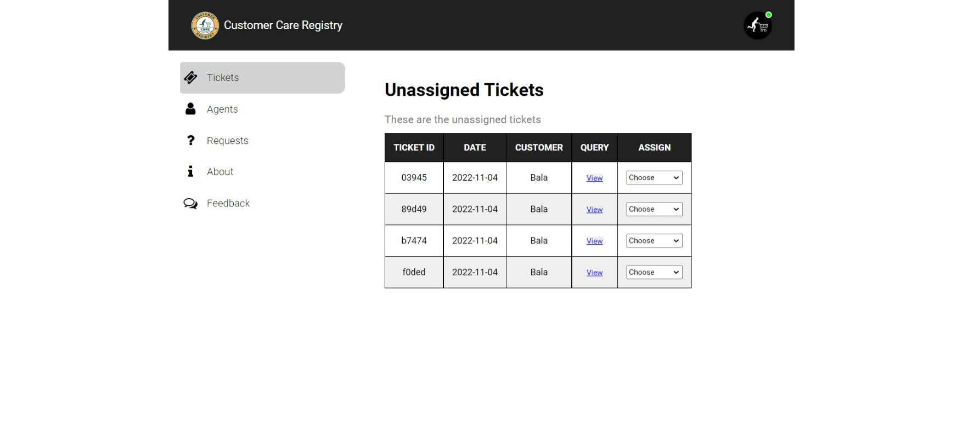](https://user-images.githubusercontent.com/87432281/200057331-0840ace8-efcf-4508-b54a-cb8088868843.jpeg)

**4. Admin - Pending requests**

[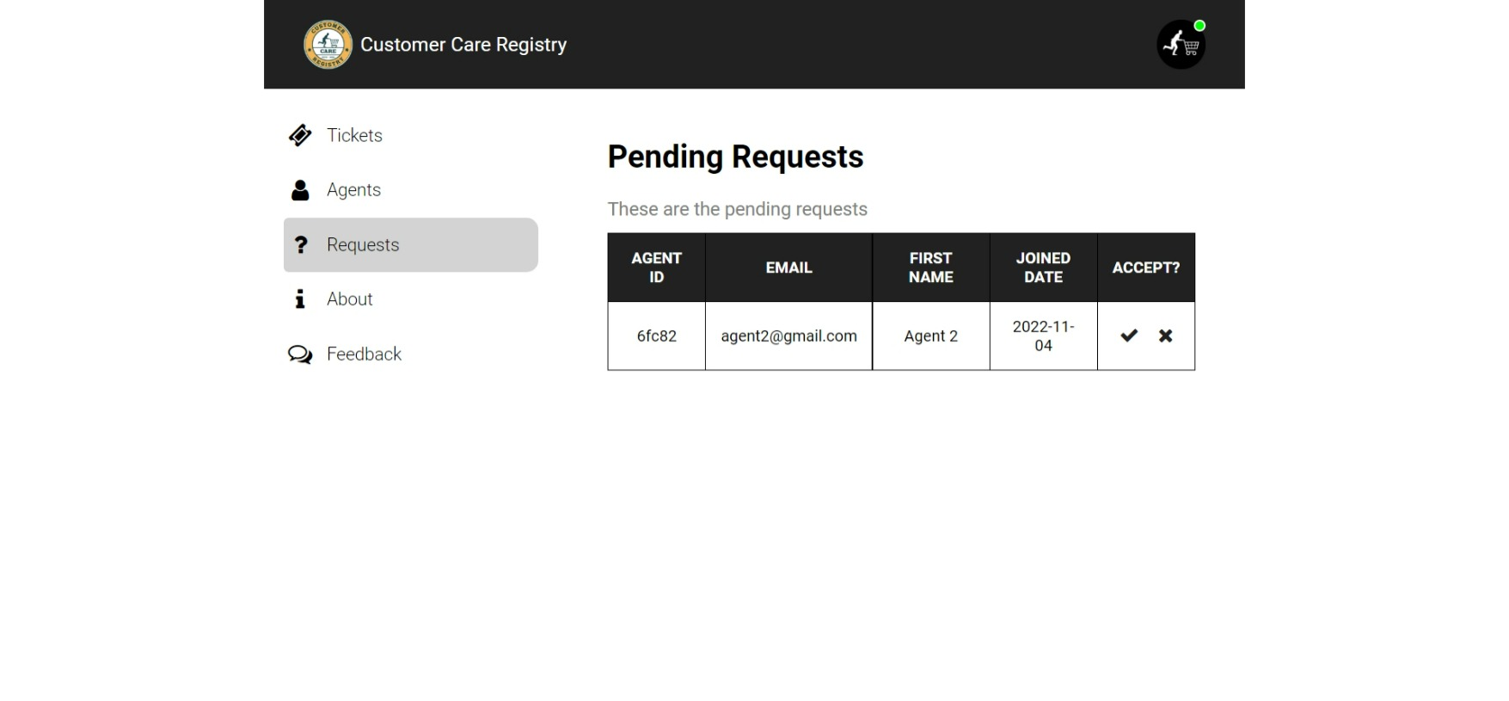](https://user-images.githubusercontent.com/87432281/200056966-6ac869d0-1c75-4a5b-b184-d322ae99f9ec.jpeg)

**5. Agent - Not confirmed by the admin**

[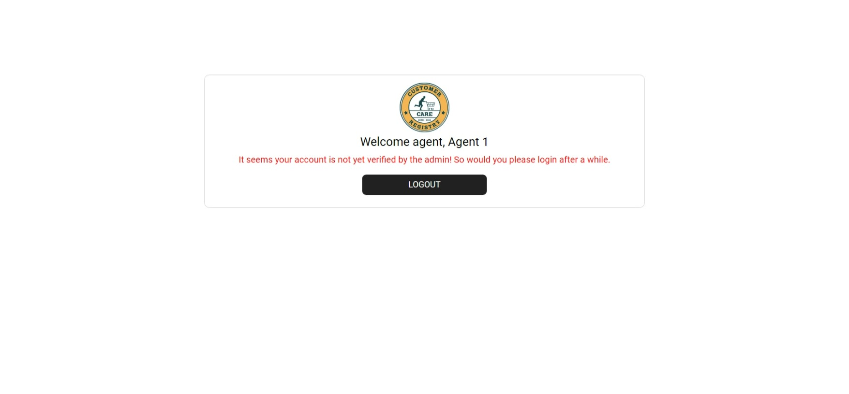](https://user-images.githubusercontent.com/87432281/200057516-3e60367c-db72-481a-8747-bbd134474223.jpeg)